Assignment No: 5
Name: Prasanna Khebade Roll No: 15 PRN: 12311687 Div: CS (AI) - B
Title: Client server programs using UDP Berkeley socket primitives.
Problem Statement: Write the client server programs using UDP Berkeley socket primitives for wired /wireless network for following a. to say Hello to Each other b. Calculator (Trigonometry).
Course Objective: To learn transport layer and application layer protocols used in the Internet.
Course Outcome: Develop Client-Servers by the means of correct standards, protocols and technologies.
Tools Required: Eclipse, Java.
Theory:
- Introduction:
The term network programming refers to writing programs that execute across multiple devices (computers), in which the devices are all connected to each other using a network.
The java.net package of the J2SE APIs contains a collection of classes and interfaces that provide the low-level communication details, allowing you to write programs that focus on solving the problem at hand.
The java.net package provides support for the two common network protocols:
TCP: TCP stands for Transmission Control Protocol, which allows for reliable communication between two applications. TCP is typically used over the Internet Protocol, which is referred to as TCP/IP.
UDP: UDP stands for User Datagram Protocol, a connection-less protocol that allows for packets of data to be transmitted between applications.
2. What is UDP?
UDP (User Datagram Protocol) is a connectionless, lightweight transport protocol that allows applications to send and receive datagrams without establishing a connection. It is faster but less reliable than TCP, as it does not guarantee delivery, ordering, or error checking.
2.1 Berkeley Sockets Model
The Berkeley Sockets API is a low-level network communication interface originally developed for UNIX systems. Java’s java.net package provides a high-level abstraction of Berkeley Sockets.
In UDP communication, Berkeley Sockets provide:
No connection establishment: Send and receive packets independently.
Datagram-based communication: Each message is sent as an individual packet.
Best-effort delivery: No guarantee of packet arrival or order.

Program:
- To say Hello to Each other:
Server:
import java.net.*;
public class UdpServer {
public static void main(String[] args) throws Exception {
DatagramSocket dsock = new DatagramSocket(5000);
byte[] receiveBuf = new byte[1024];
DatagramPacket recvPack = new DatagramPacket(receiveBuf, receiveBuf.length);
dsock.receive(recvPack);
String receivedMsg = new String(recvPack.getData(), 0, recvPack.getLength());
System.out.println("Received: " + receivedMsg);

String replyMsg = "Hello from Server";
byte[] sendBuf = replyMsg.getBytes();
InetAddress clientAddr = recvPack.getAddress();
int clientPort = recvPack.getPort();
DatagramPacket sendPack = new DatagramPacket(sendBuf, sendBuf.length, clientAddr, clientPort);
dsock.send(sendPack);
dsock.close();
}
}

Client:
import java.net.*;

public class UdpClient {
public static void main(String[] args) throws Exception {
DatagramSocket csock = new DatagramSocket();
String sendMsg = "Hello from Client";
byte[] outBuf = sendMsg.getBytes();
InetAddress serverAddr = InetAddress.getByName("localhost");
DatagramPacket outPack = new DatagramPacket(outBuf, outBuf.length, serverAddr, 5000);
csock.send(outPack);

byte[] inBuf = new byte[1024];
DatagramPacket inPack = new DatagramPacket(inBuf, inBuf.length);
csock.receive(inPack);
String serverReply = new String(inPack.getData(), 0, inPack.getLength());
System.out.println("Server Reply: " + serverReply);
csock.close();
}
}

Result:
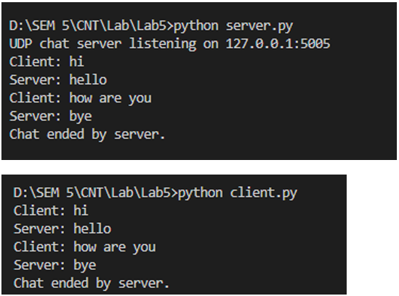
- Calculator (Trigonometry)
Server:
package Calculator;

import java.net.DatagramPacket;
import java.net.DatagramSocket;
import java.util.StringTokenizer;

public class Server {
public static void main(String[] args) throws Exception {
DatagramSocket udpServer = new DatagramSocket(9877);
byte[] bufIn = new byte[1024];
byte[] bufOut;

while (true) {
DatagramPacket pktIn = new DatagramPacket(bufIn, bufIn.length);
udpServer.receive(pktIn);
String reqData = new String(pktIn.getData(), 0, pktIn.getLength());

StringTokenizer tokens = new StringTokenizer(reqData, " ");
String cmd = tokens.nextToken();
double angle = Double.parseDouble(tokens.nextToken());

double res;
switch (cmd.toLowerCase()) {
case "sin": res = Math.sin(Math.toRadians(angle)); break;
case "cos": res = Math.cos(Math.toRadians(angle)); break;
case "tan": res = Math.tan(Math.toRadians(angle)); break;
default: res = Double.NaN;
}

String strResult = "Result: " + res;
bufOut = strResult.getBytes();
DatagramPacket pktOut = new DatagramPacket(bufOut, bufOut.length,
pktIn.getAddress(), pktIn.getPort());
udpServer.send(pktOut);
}
}
}

Client:
import java.net.DatagramPacket;
import java.net.DatagramSocket;
import java.net.InetAddress;
import java.util.Scanner;

public class Client {
public static void main(String[] args) throws Exception {
DatagramSocket sock = new DatagramSocket();
InetAddress hostAddr = InetAddress.getByName("localhost");
Scanner keyboard = new Scanner(System.in);

while (true) {
System.out.print("Enter operator (sin/cos/tan): ");
String operator = keyboard.next();
System.out.print("Enter number: ");
double value = keyboard.nextDouble();

String dataToSend = operator + " " + value;
byte[] sendBytes = dataToSend.getBytes();
DatagramPacket packetOut = new DatagramPacket(sendBytes, sendBytes.length, hostAddr, 9877);
sock.send(packetOut);

byte[] recvBytes = new byte[1024];
DatagramPacket packetIn = new DatagramPacket(recvBytes, recvBytes.length);
sock.receive(packetIn);
String serverMsg = new String(packetIn.getData(), 0, packetIn.getLength());
System.out.println(serverMsg);

System.out.print("Do you want to continue? (yes/no): ");
if (!keyboard.next().equalsIgnoreCase("yes")) break;
}

sock.close();
keyboard.close();
}
}

Result:
